Data Flow Diagram and User Stories
Requirement Analysis | Request lifecycle and acceptance criteria
Project | Automated Network Request Management | Date | 20 October 2026
Owner / demonstrator | PILLEM RAHUL | SkillWallet ID | SWUID2026232277
Platform | ServiceNow PDI | Repository | https://github.com/rahulp06/Automated_Network_Request_Management_in_ServiceNow

Phase: 2. Requirement Analysis

Data flow
The diagram represents the observed high-level process. It intentionally avoids claiming uninspected internal flow steps or custom APIs.
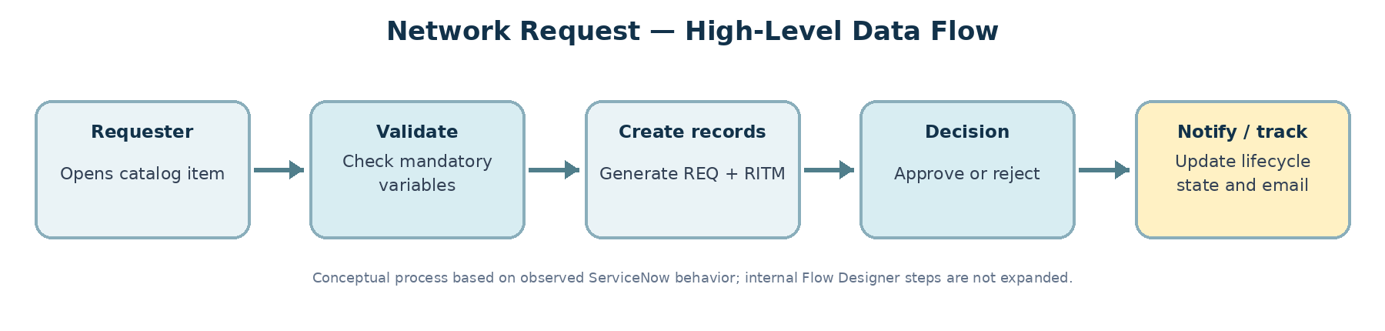
Figure 1. High-level Network Request data flow (conceptual, based on observed behavior).

User stories and acceptance criteria
Story | As a… | I want… | Acceptance criteria | Priority
US-01 | Requester | Open a Network Request catalog item. | The item and ordering form are accessible from Service Catalog. | High
US-02 | Requester | Be prevented from submitting missing mandatory information. | Order Now is blocked when a starred variable is blank. | High
US-03 | Requester | Receive an identifiable request and item record. | A REQ and linked RITM are created; the reference is consistent. | High
US-04 | Approver | Approve or reject an eligible request. | Existing approval/rejection path executes and decision outcome is reflected. | High
US-05 | Requester / service team | Receive lifecycle notifications. | Submission/created/approval notifications are generated and delivered to QA inbox. | High
US-06 | ServiceNow administrator | Check mail-processing status. | Diagnostics show sender state, last-sent timestamp and queue count. | Medium
US-07 | Service team | Distinguish approval from fulfillment completion. | RITM stage/state remain visible; Open state after approval is not falsely treated as fulfilled. | Medium

